INF2003: Database Systems
Lab 03: Complex SQL Queries

Preparation Step
Download and run the SQL script (sample_data.sql) for the creation of the relational schema and insertion of data from LMS.

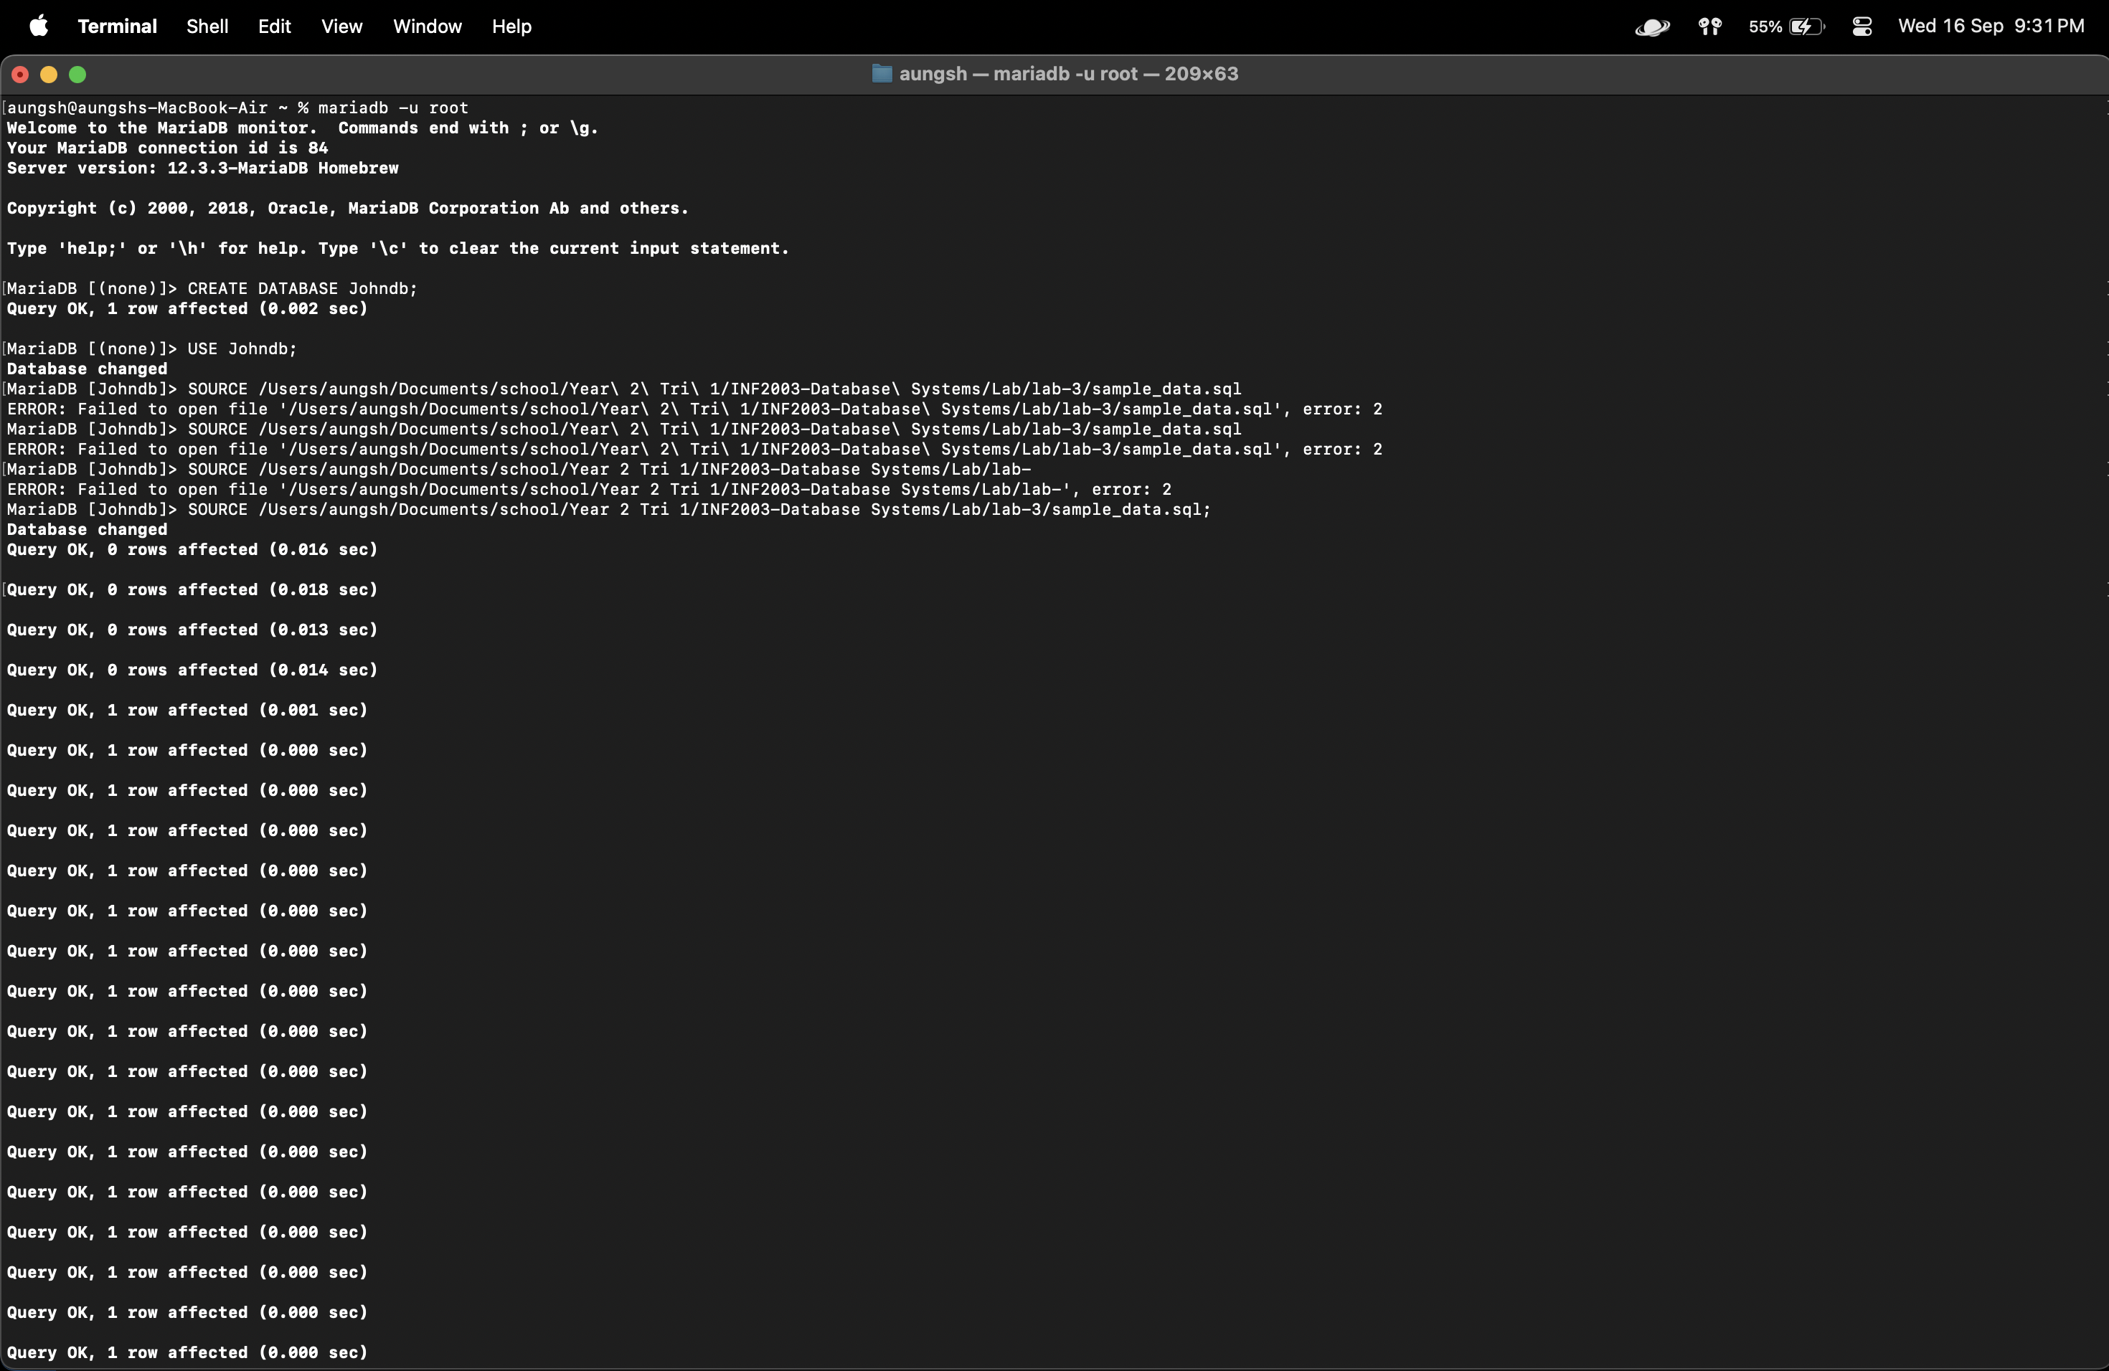

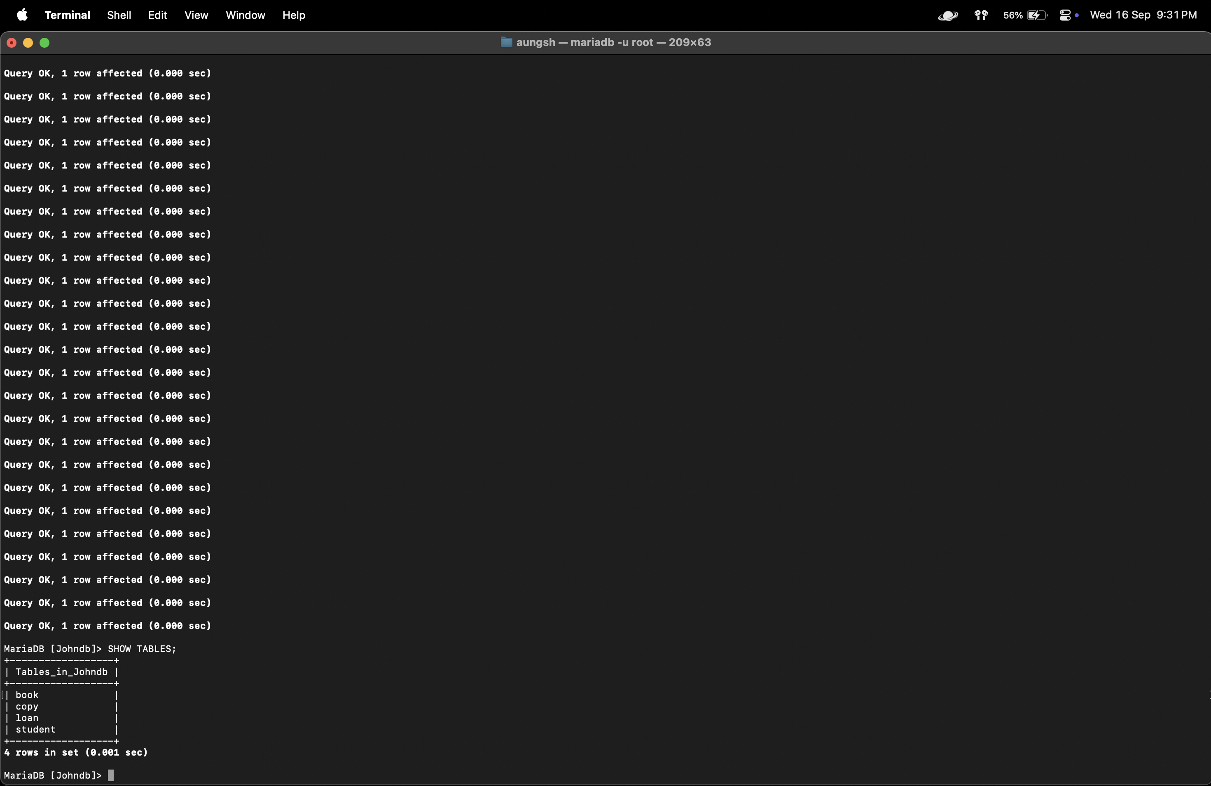

CREATE DATABASE Johndb;
USE Johndb;
SOURCE /Users/aungsh/Documents/school/Year 2 Tri 1/INF2003-Database Systems/Lab/lab-3/sample_data.sql;
SHOW TABLES;
Exercise: Queries in SQL.
(Note: Remember to save your work and screen capture your SQL queries and output for your lab submission.)

- Find the emails of students.
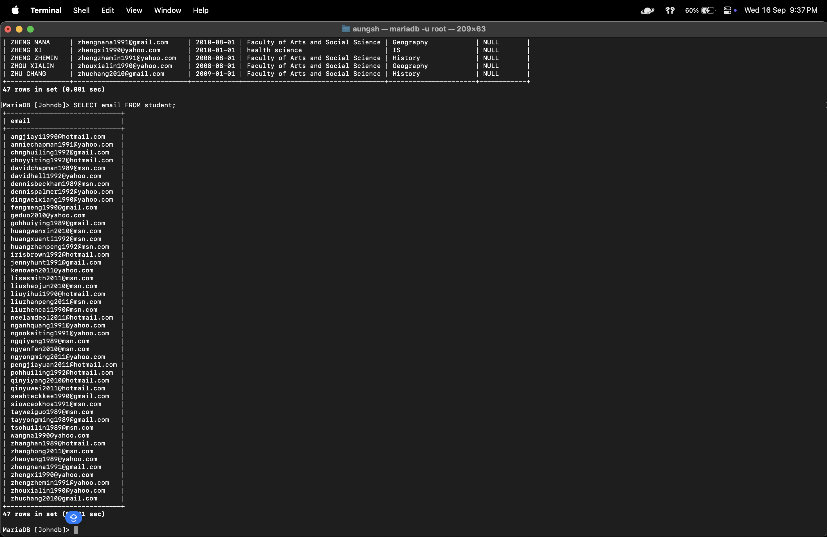

SELECT email FROM student;

- Find the different emails of students. (Do we need to use DISTINCT?)
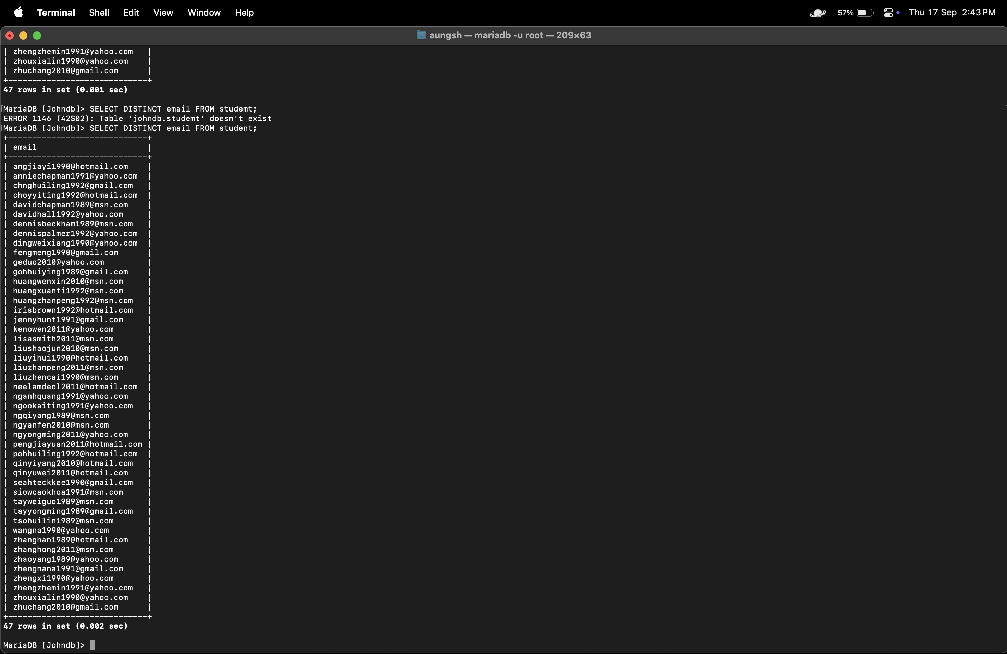

SELECT DISTINCT email FROM student;

- Print the names of students in descending alphabetical order.
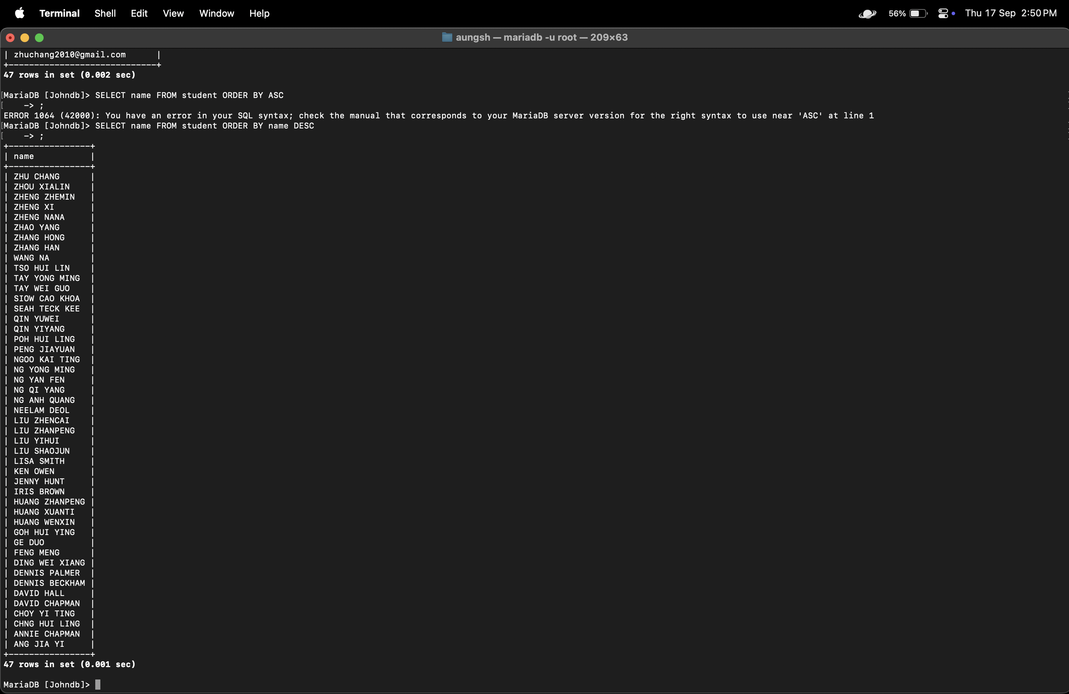

SELECT name FROM student ORDER BY name DESC;

- Find out if there are students with the same name?
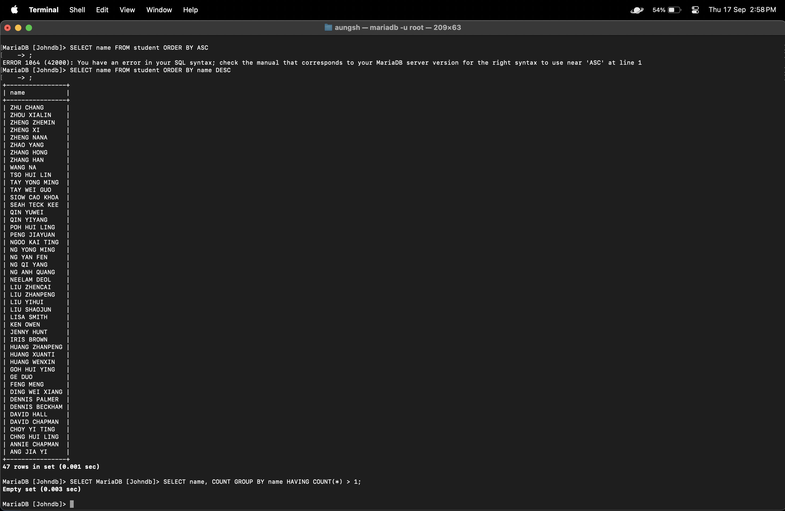
SELECT name, COUNT GROUP BY name HAVING COUNT(*) > 1;

- Find the different names of students. Is the result sorted? If not, please sort it.
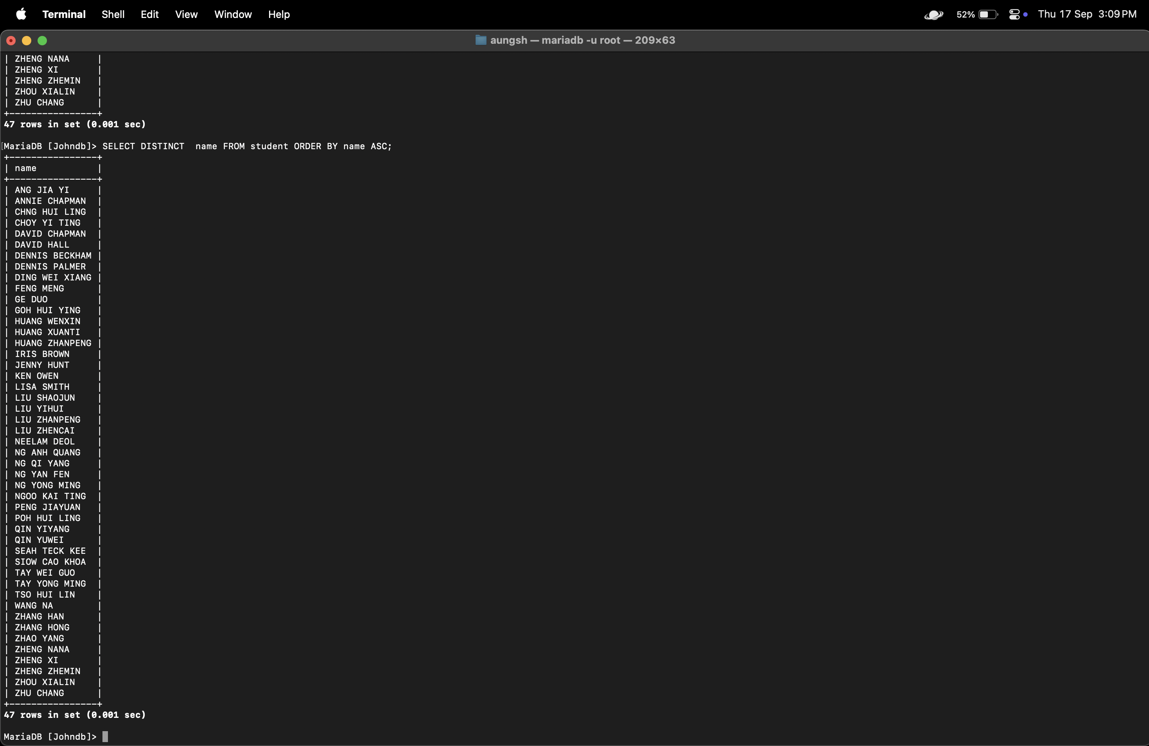
SELECT DISTINCT name FROM student ORDER BY name ASC;

- Find the names of students who owned a copy of the book ‘978-0321474049’.
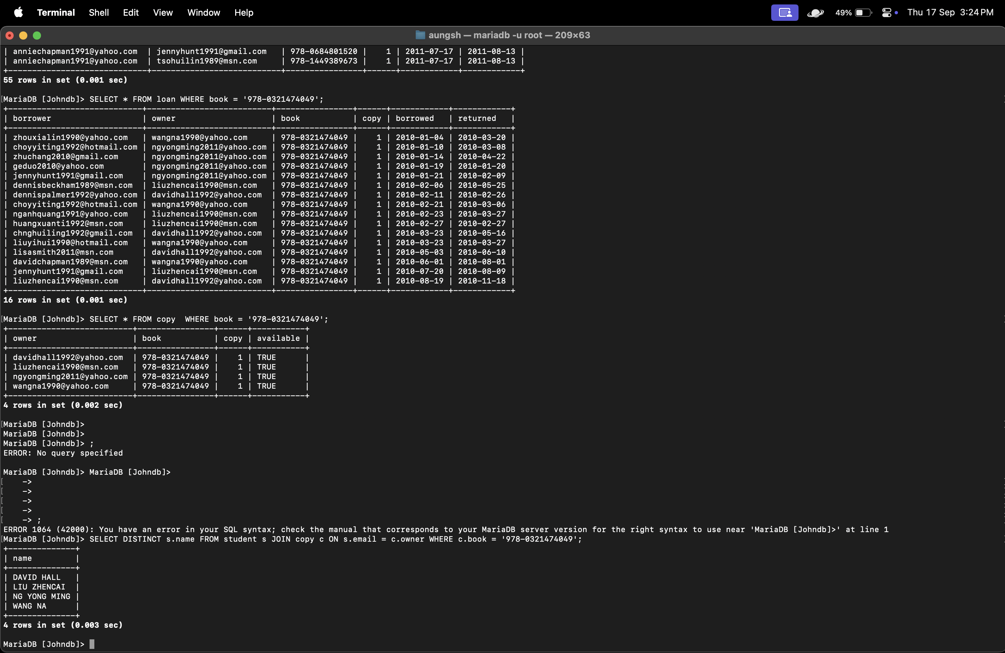
SELECT DISTINCT s.name FROM student s JOIN copy c ON s.email = c.owner WHERE c.book = '978-0321474049';

- Find the names of the students who owned a copy of a book with more than 100 pages and the book title contains the word ‘Photoshop’.
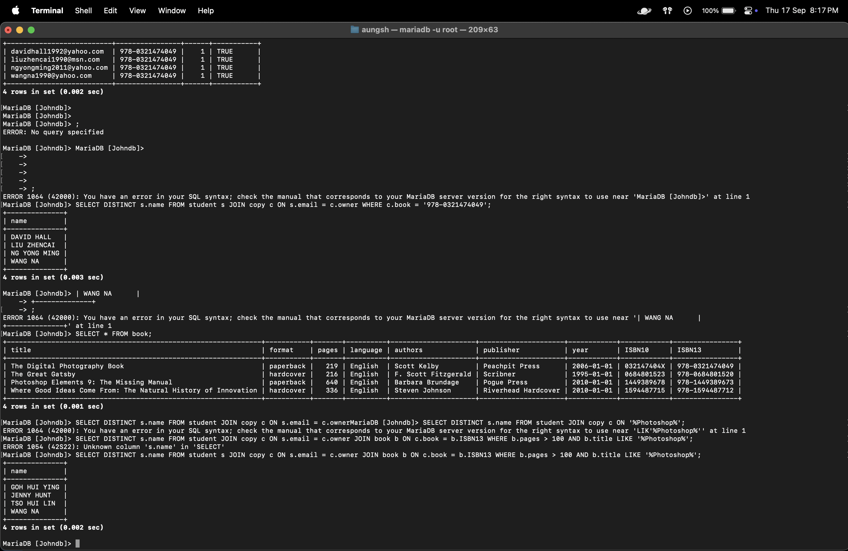

SELECT DISTINCT s.name FROM student s JOIN copy c ON s.email = c.owner JOIN book b ON c.book = b.ISBN13 WHERE b.pages > 100 AND b.title LIKE '%Photoshop%';

- Find the number of A4 paper needed to photocopy the two books with ISBN-13 ‘978-0321474049’ and ‘978-0684801520’ (duplex printing, or 2 pages of a book can be copied on one A4 paper).
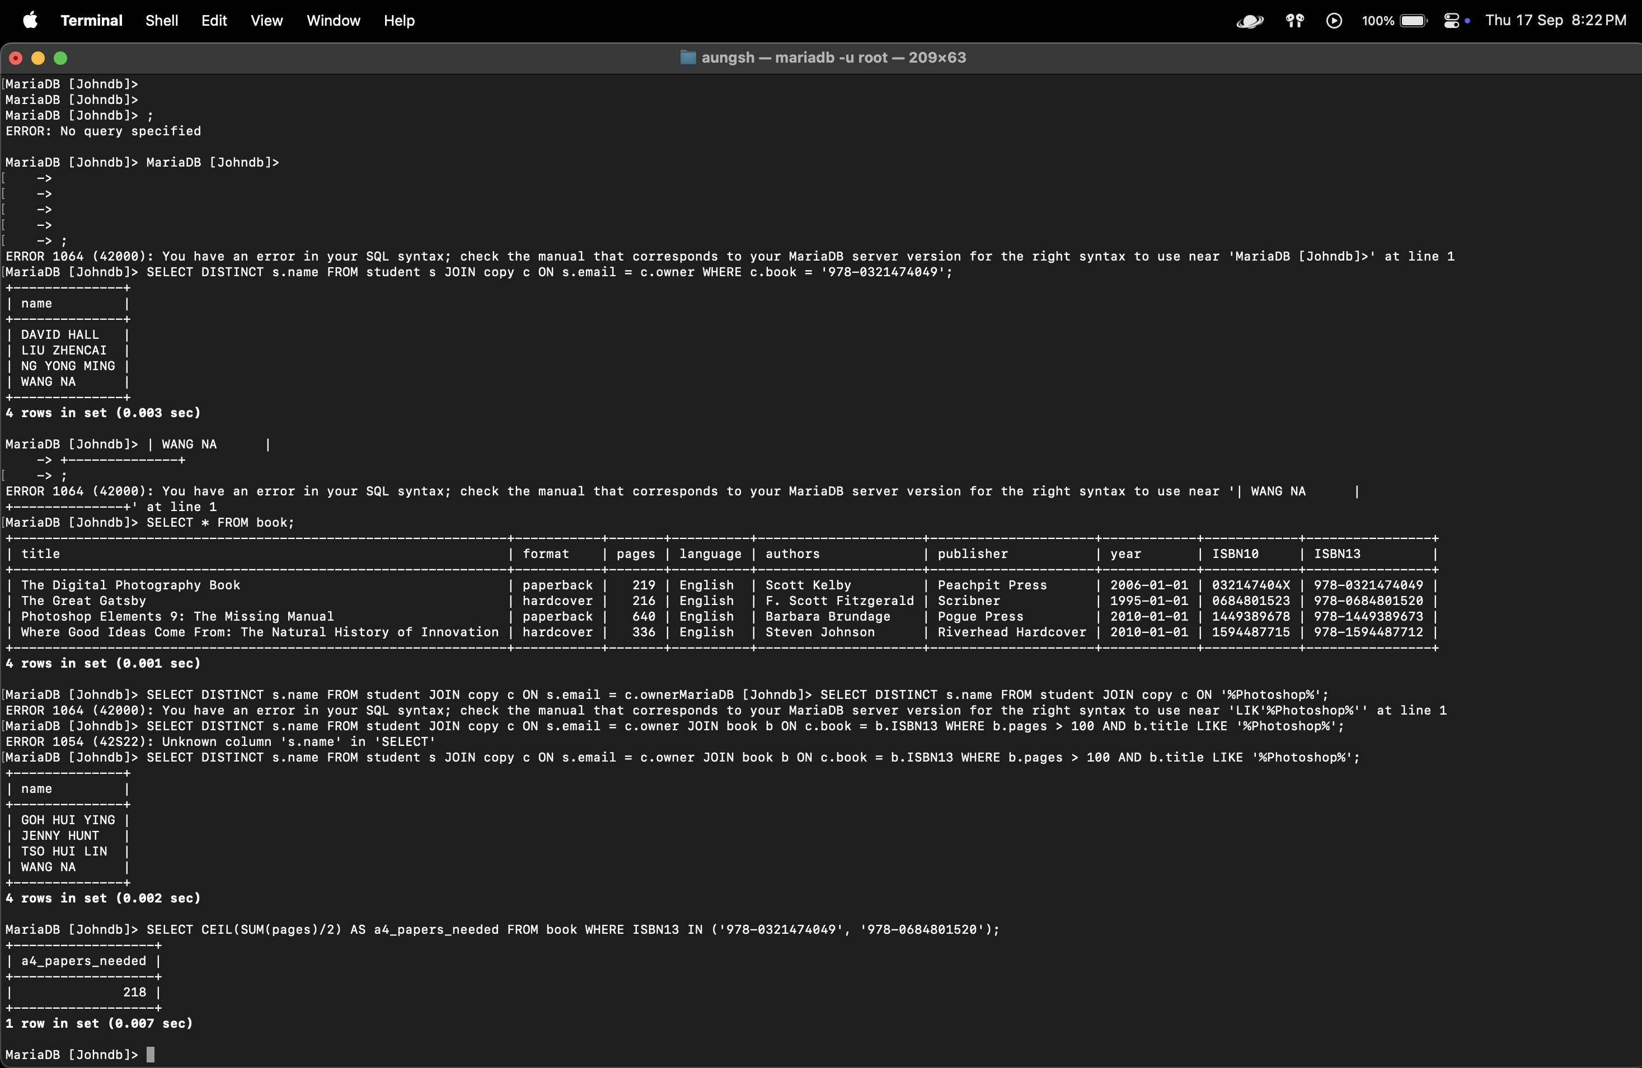

SELECT CEIL(SUM(pages)/2) AS a4_papers_needed FROM book WHERE ISBN13 IN ('978-0321474049', '978-0684801520');

- Find the different names of the students who owned a copy of a book other than ‘978-0321474049’. (Hint: a student may own multiple books)
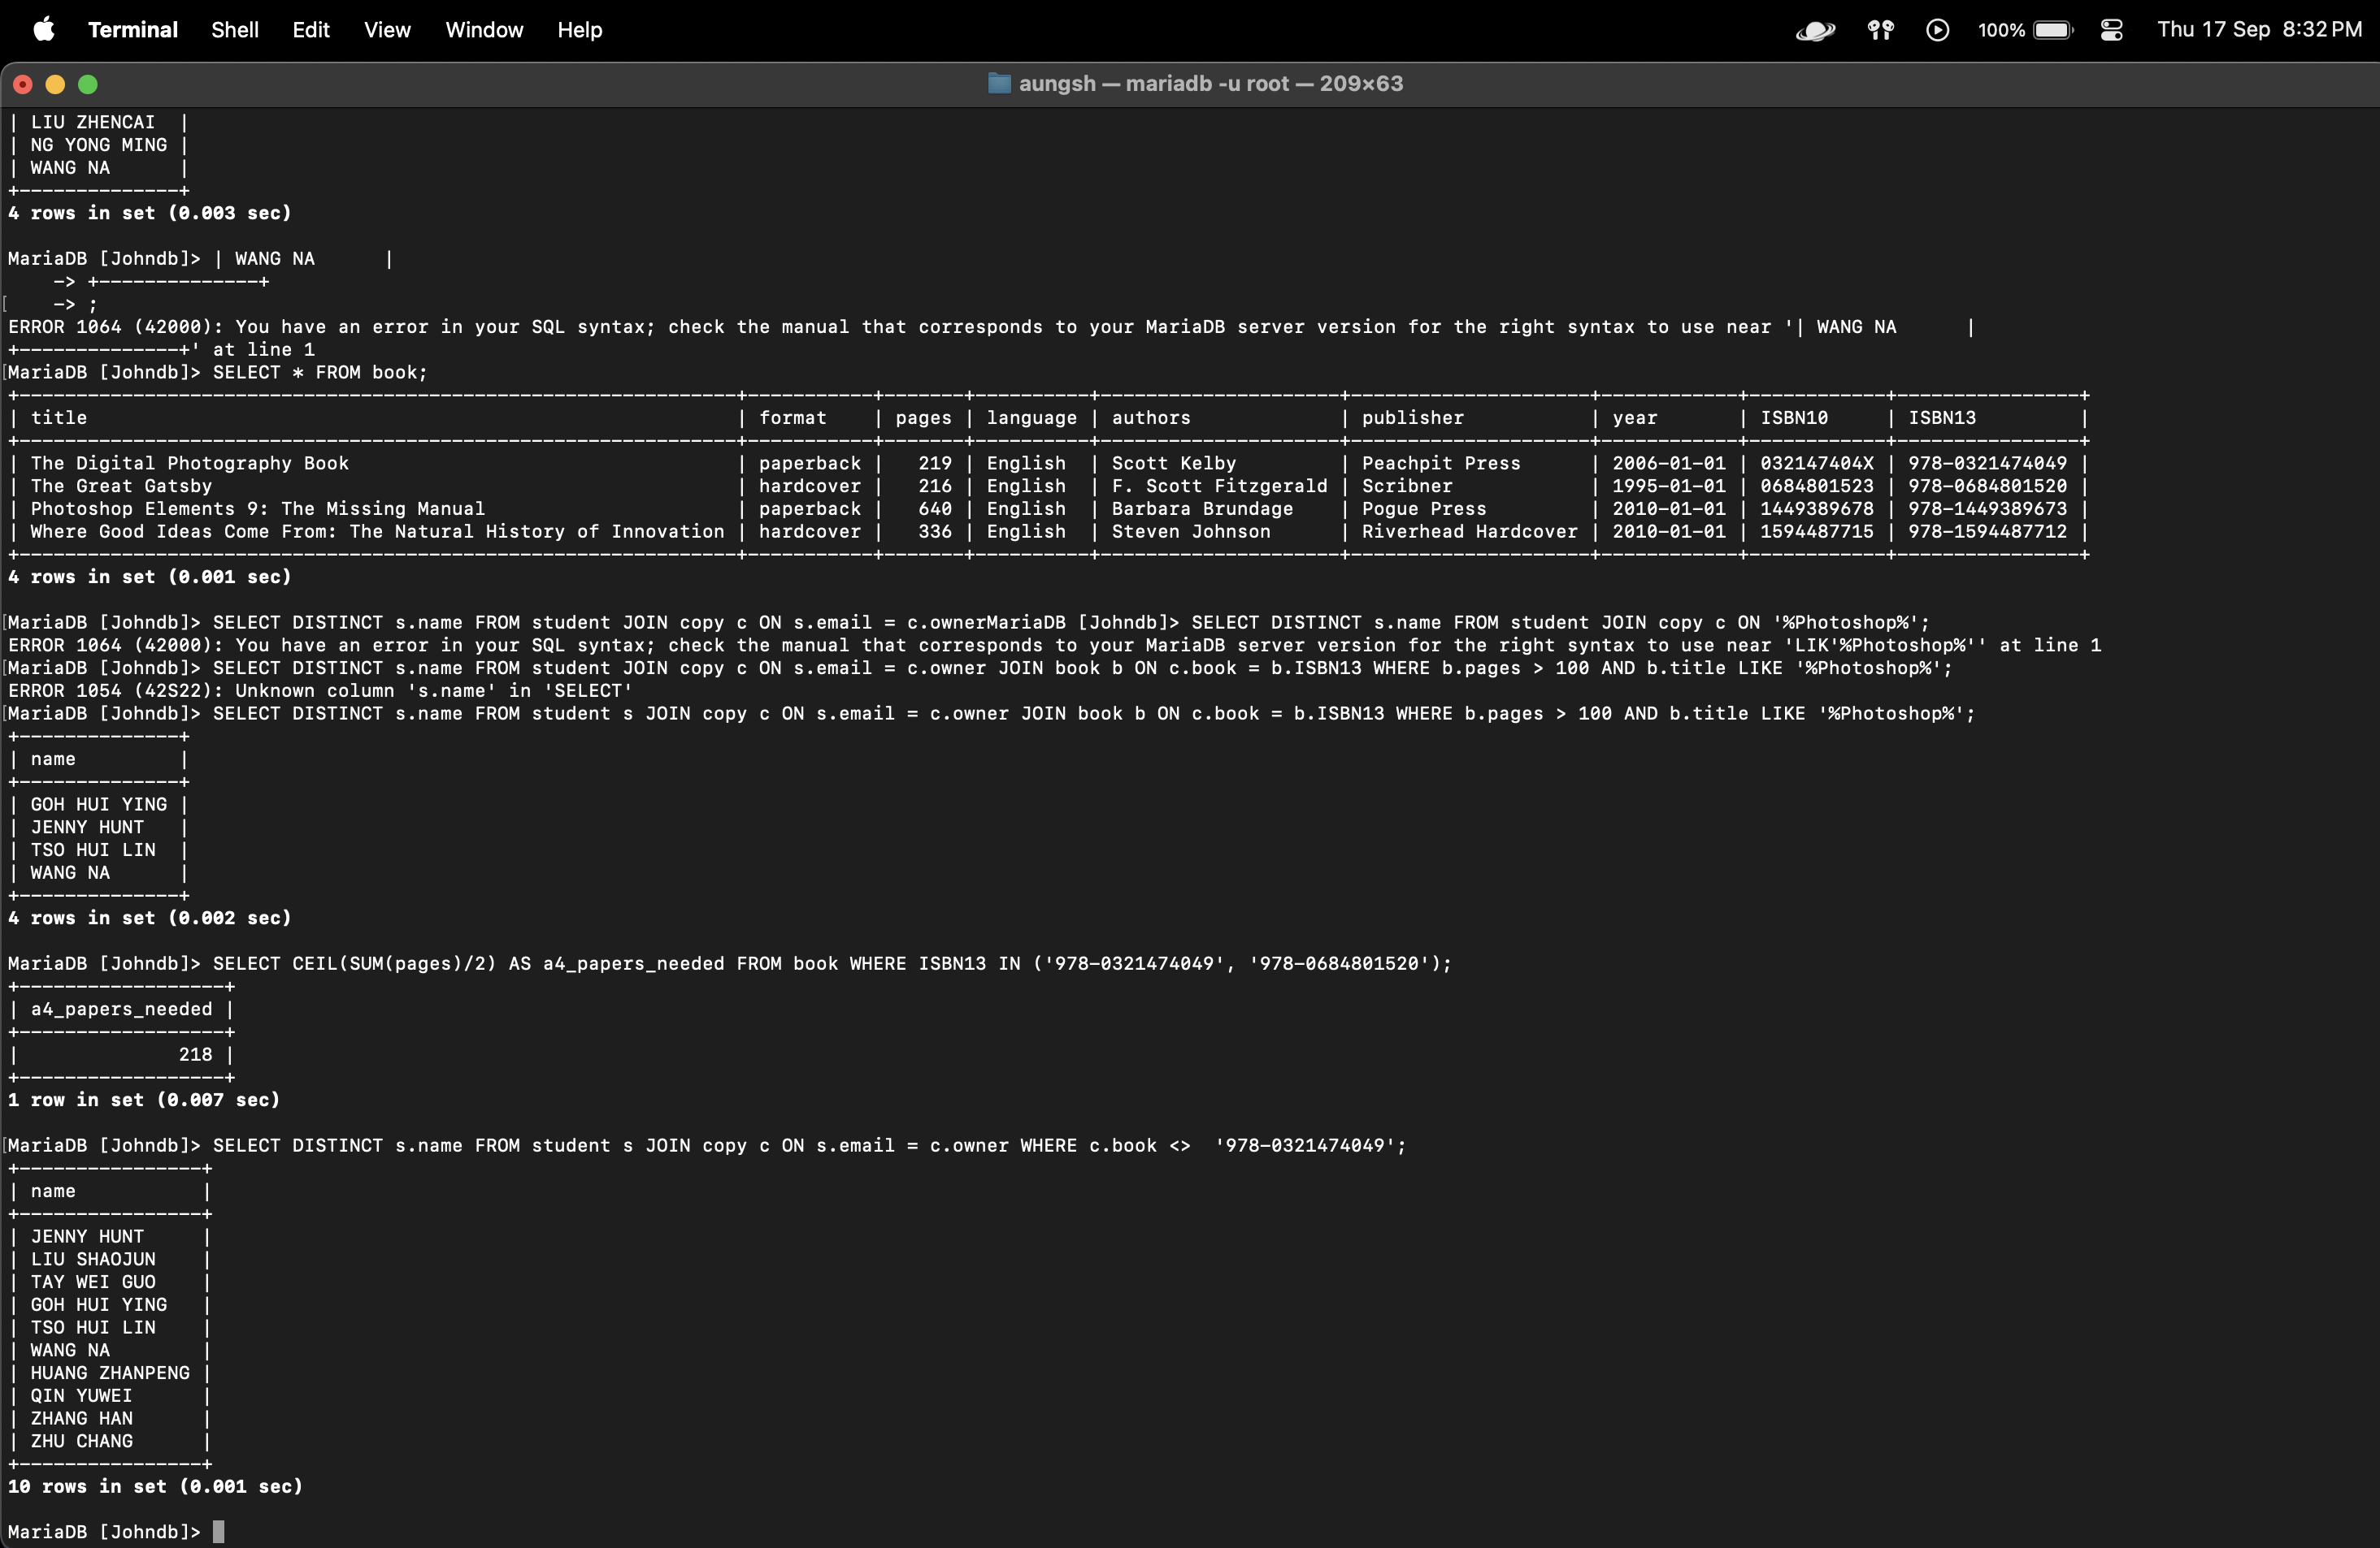
SELECT DISTINCT s.name FROM student s JOIN copy c ON s.email = c.owner WHERE c.book <> '978-0321474049'

- Find the names of students who borrowed a copy of the book '978-0321474049'.
<YOUR INPUT HERE>
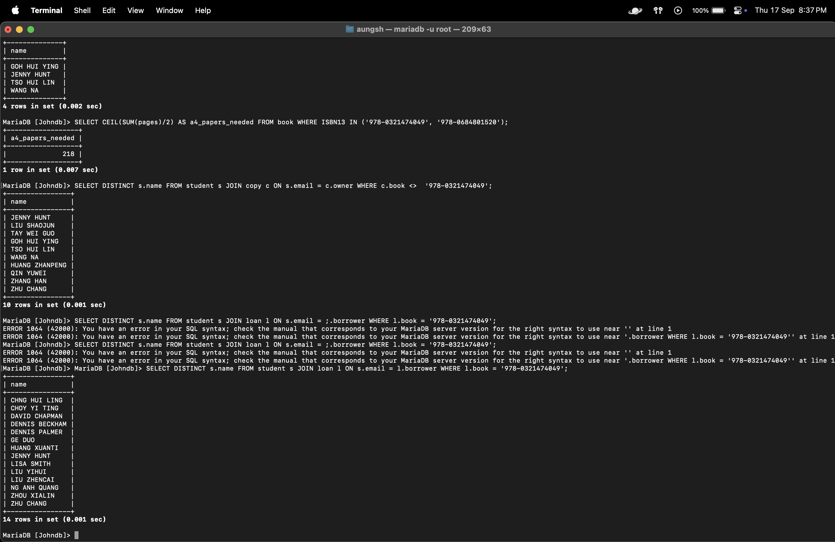
SELECT DISTINCT s.name FROM student s JOIN loan l ON s.email = l.borrower WHERE l.book = '978-0321474049';

- Find the names of students who owned or borrowed a copy of the book ‘978-0321474049’ using set operator UNION.
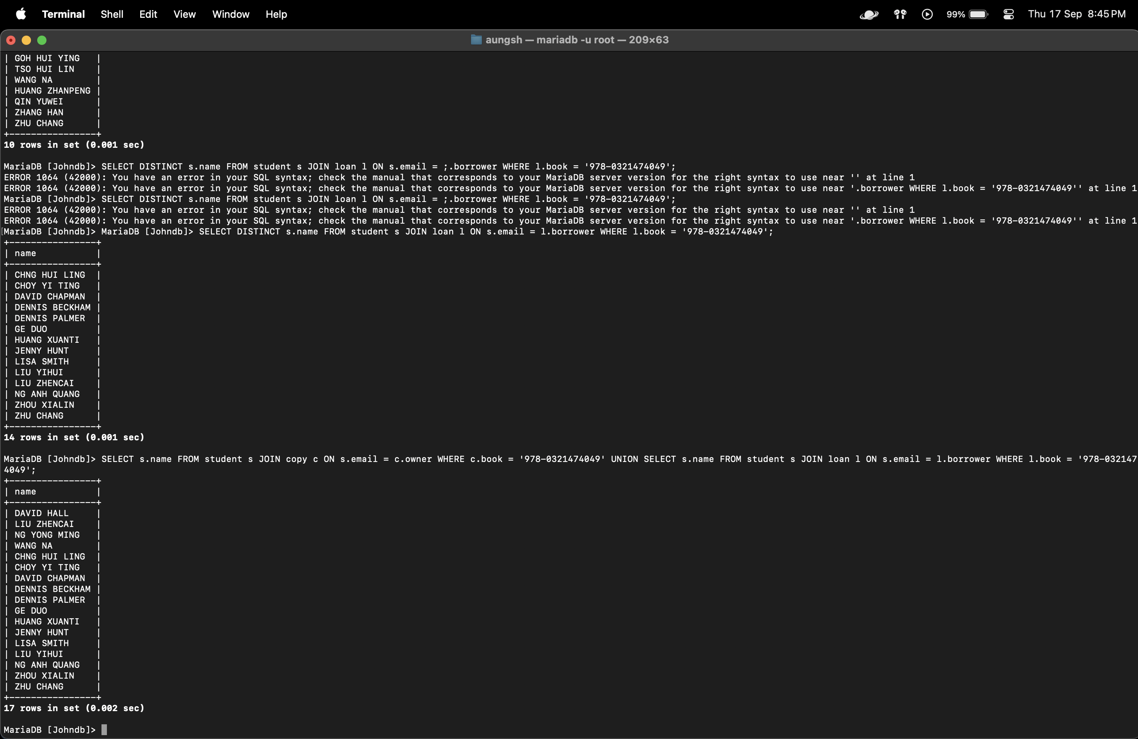
SELECT s.name FROM student s JOIN copy c ON s.email = c.owner WHERE c.book = '978-0321474049' UNION SELECT s.name FROM student s JOIN loan l ON s.email = l.borrower WHERE l.book = '978-0321474049';
- Find the names of students who owned or borrowed a copy of the book ‘978-0321474049’ using logical operator OR.
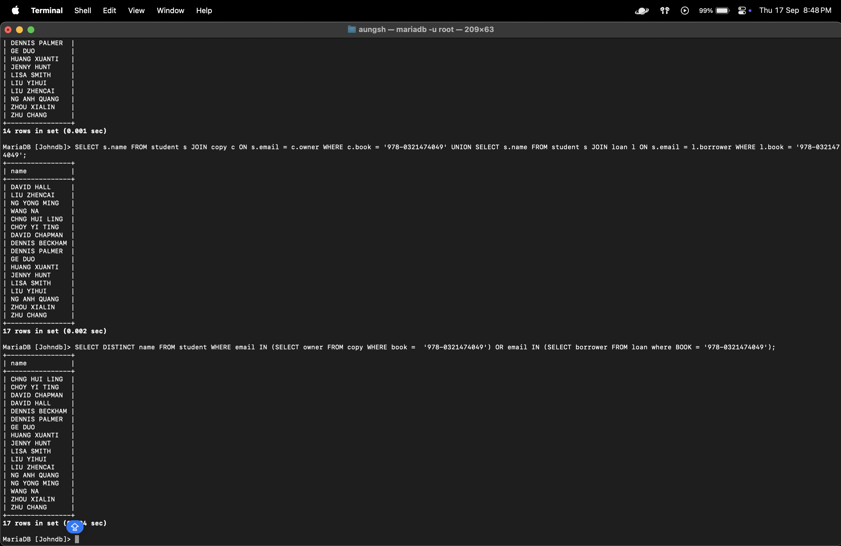
SELECT DISTINCT name FROM student WHERE email IN (SELECT owner FROM copy WHERE book = '978-0321474049') OR email IN (SELECT borrower FROM loan where BOOK = '978-0321474049');

- Delete all the data in table loan. (Hint: do not delete the table)

Try the Q12 query again, and comment on the results.
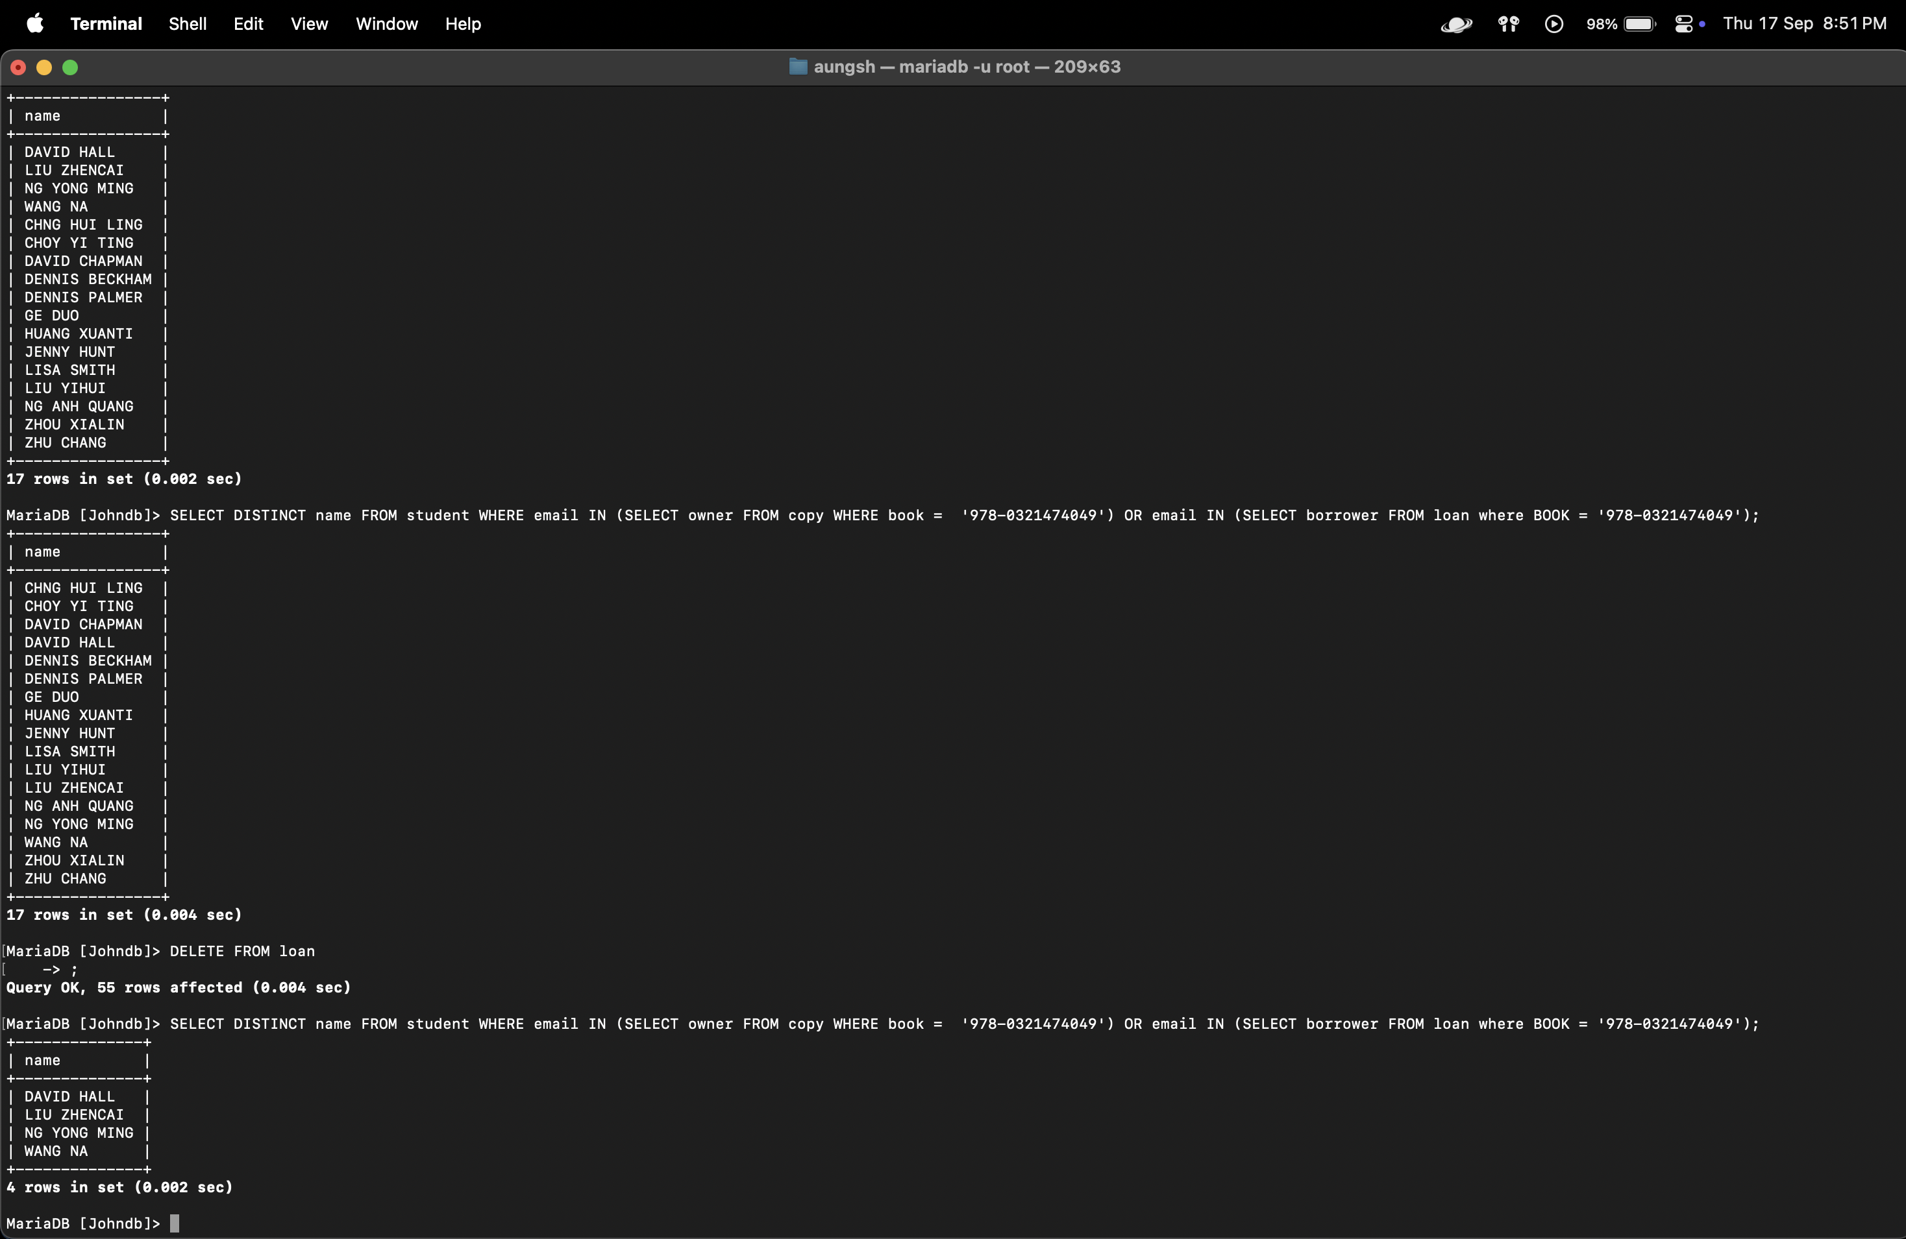
DELETE FROM loan;
SELECT DISTINCT name FROM student WHERE email IN (SELECT owner FROM copy WHERE book = '978-0321474049') OR email IN (SELECT borrower FROM loan where BOOK = '978-0321474049');

Only the students who owned the book are returned. Since the loan table is empty, no borrowers are found, but the owners are preserved.

